Our campuses
The University has four campuses each with its own character:
- Penrhyn Road – the hub of student activity in Kingston
- Kingston Hill – a modern hillside campus set in landscaped gardens
- Knights Park – a relaxed and friendly atmosphere in a riverside setting
- Roehampton Vale – a modern building close to Richmond Park
These are linked by our free intersite bus
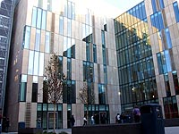 | 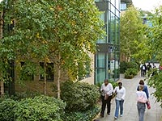
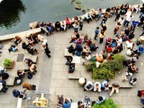 | 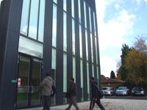

More information about Kingston can be found from the University Web Site [Note to web designer – place a hyperlink to the main University address www.kingston.ac.uk on these last three words]

